Final Report By Hui Ji (huj16@pitt.edu)
(i) Title: PM2.5 Concentration Trends in Pittsburgh Neighborhoods (2015–2024)
(ii) Main Figure: (ideally an integrated version comprising both the main one and small panels on the side)
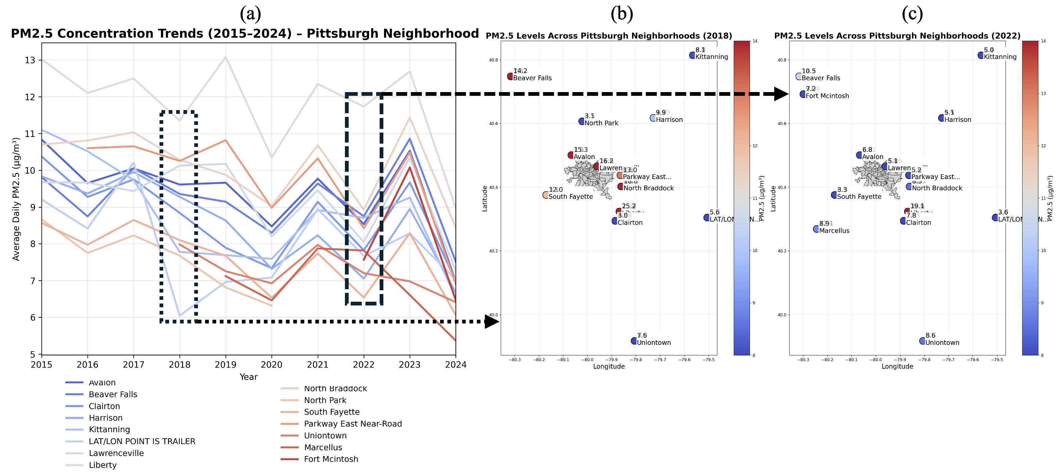
- Panel (a): Year-to-year PM2.5 concentration trends across Pittsburgh Neighborhoods.
- Panel (b): Geographical PM2.5 distribution in 2018.
- Panel (c): Geographical PM2.5 distribution in 2022.
(iii) Legend Explanation:
- Colored Lines (Panel a):Panel (a) visualizes year-to-year PM2.5 concentration trends for all monitoring neighborhoods across the Pittsburgh region from 2015 to 2024. The following elements appear in the plot:
- Each line represents the annual average PM2.5 concentration measured at one monitoring neighborhood.
- X-Axis (Year), Y-Axis (Average Daily PM2.5 (µg/m³)).
- Colors are assigned uniquely to each neighborhood for visual distinction only; the color does not encode magnitude or category.
- Line shapes and directions reveal:
  - Long-term trends (decline, increase, or plateau)
  - Year-to-year variability
  - Neighborhoods with consistently high or low PM2.5 levels
This allows comparison of pollution trajectories across different areas.
- Solid Points in Panels (b) and (c):
Each point represents a monitoring site.
  - Color scale: PM2.5 concentration (blue = low, red = high).
  - Numeric label: Actual PM2.5 value measured at that location.
  - Text label: Neighborhood name.
- Gray Polygons (b) and (c):
Pittsburgh administrative neighborhood boundaries from GIS shapefile.
- Color Bar:
Quantitative mapping of PM2.5 concentration (µg/m³) to a blue–red color gradient.
- Dashed Boxes and Arrows (Panel a → b → c):
Highlight selected years (2018 and 2022) used for detailed spatial visualization.
(v) data and method:

Data Sources (https://www.epa.gov/outdoor-air-quality-data/download-daily-data)
- EPA Air Quality Monitoring Dataset (2015–2024)
Files: ad_viz_plotval_data_2015.csv, …, ad_viz_plotval_data_2024.csv
Includes:
  - Latitude & longitude of monitoring sites
  - Local Site Name (interpreted as neighborhood)
  - Daily Mean PM2.5 Concentration
- Pittsburgh Neighborhood Boundary Shapefile
Files: Neighborhoods_.shp, .dbf, .shx, .prj, .cpg
Used for accurate geographic boundary overlays.

Method Summary
- Data Cleaning & Standardization
  - Harmonized column names.
  - Filtered valid PM2.5 measurements.
  - Converted geographic coordinates into a GeoDataFrame.
- Trend Analysis (Panel a)
  - Aggregated daily PM2.5 to yearly averages per neighborhood.
  - Produced multi-line time-series visualization using Matplotlib/Seaborn.
- Spatial Analysis (Panels b & c)
  - Spatial join: matched PM2.5 monitoring points to neighborhood polygons.
  - Overlayed point measurements on geographic neighborhoods.
  - Labeled points with PM2.5 value + Local Site Name.
  - Used a controlled color range for consistent visual comparison.
- Visualization Integration
  - Combined trend plot and two spatial panels into a single multi-panel figure.
  - Added annotations linking temporal trends to spatial snapshots.
(vi) significance statement:
Understanding neighborhood-level PM2.5 pollution is essential for:
- Environmental justice: identifies communities disproportionately exposed to harmful air pollution.
- Public health planning: PM2.5 is linked to cardiovascular disease, asthma, and premature mortality.
- Urban policy: supports targeted interventions such as emission controls, zoning changes, or traffic redirection.
- Long-term monitoring: reveals persistent hotspots and evaluates effectiveness of clean-air initiatives.
The integrated figure (trends + spatial maps) provides a comprehensive picture of how pollution evolves over time and how it is distributed across the Pittsburgh metropolitan area—insights not visible from either temporal or spatial analysis alone.
Github:
https://github.com/HuiJi-1024/Final-Project-for-INFSCI-2415-huj16-pitt.edu-

